**Decision Tree Algorithm**

A decision tree algorithm is a machine learning algorithm that uses a decision tree to make predictions. It is called so because it follows a tree-like model of decisions and their possible consequences. The algorithm works by recursively splitting the data into subsets based on the most significant feature at each node of the tree.  
Decision Tree is a **Supervised learning technique**that can be used for both classification and Regression problems, but mostly it is preferred for solving Classification problems. It is a tree-structured classifier, where**internal nodes represent the features of a dataset, branches represent the decision rules** and **each leaf node represents the outcome.**

* In a Decision tree, there are two nodes, which are the **Decision Node** and**Leaf Node.** Decision nodes are used to make any decision and have multiple branches, whereas Leaf nodes are the output of those decisions and do not contain any further branches.
* The decisions or the test are performed on the basis of features of the given dataset.
* **It is a graphical representation for getting all the possible solutions to a problem/decision based on given conditions.**
* It is called a decision tree because, similar to a tree, it starts with the root node, which expands on further branches and constructs a tree-like structure.
* In order to build a tree, we use the **CART algorithm,** which stands for **Classification and Regression Tree algorithm.**
* A decision tree simply asks a question, and based on the answer (Yes/No), it further split the tree into subtrees.
* Below diagram explains the general structure of a decision tree:

**Note: A decision tree can contain categorical data (YES/NO) as well as numeric data.**

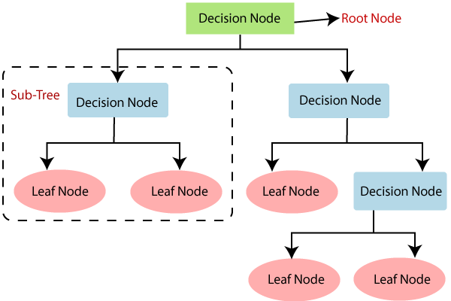

## Why use Decision Trees?

There are various algorithms in Machine learning, so choosing the best algorithm for the given dataset and problem is the main point to remember while creating a machine learning model. Below are the two reasons for using the Decision tree:

* Decision Trees usually mimic human thinking ability while making a decision, so it is easy to understand.
* The logic behind the decision tree can be easily understood because it shows a tree-like structure.
* One of the many qualities of Decision Trees is that they require very little data preparation. In particular, they don’t require feature scaling or centering at all.

## Decision Tree Terminologies

• **Root Node:** Root node is from where the decision tree starts. It represents the entire dataset, which further gets divided into two or more homogeneous sets.

• **Leaf Node:** Leaf nodes are the final output node, and the tree cannot be segregated further after getting a leaf node.

• **Splitting:** Splitting is the process of dividing the decision node/root node into sub-nodes according to the given conditions.

• **Branch/Sub Tree:** A tree formed by splitting the tree.

• **Pruning:** Pruning is the process of removing the unwanted branches from the tree.

• **Parent/Child node:** The root node of the tree is called the parent node, and other nodes are called the child nodes.

**How does the Decision Tree algorithm Work?**

In a decision tree, for predicting the class of the given dataset, the algorithm starts from the root node of the tree. This algorithm compares the values of root attribute with the record (real dataset) attribute and, based on the comparison, follows the branch and jumps to the next node.

For the next node, the algorithm again compares the attribute value with the other sub-nodes and move further. It continues the process until it reaches the leaf node of the tree. The complete process can be better understood using the below algorithm:

* **Step-1:** Begin the tree with the root node, says S, which contains the complete dataset.
* **Step-2:** Find the best attribute in the dataset using **Attribute Selection Measure (ASM).**
* **Step-3:** Divide the S into subsets that contains possible values for the best attributes.
* **Step-4:** Generate the decision tree node, which contains the best attribute.
* **Step-5:** Recursively make new decision trees using the subsets of the dataset created in step -3. Continue this process until a stage is reached where you cannot further classify the nodes and called the final node as a leaf node.

**Example:** Suppose there is a candidate who has a job offer and wants to decide whether he should accept the offer or Not. So, to solve this problem, the decision tree starts with the root node (Salary attribute by ASM). The root node splits further into the next decision node (distance from the office) and one leaf node based on the corresponding labels. The next decision node further gets split into one decision node (Cab facility) and one leaf node. Finally, the decision node splits into two leaf nodes (Accepted offers and Declined offer). Consider the below diagram:

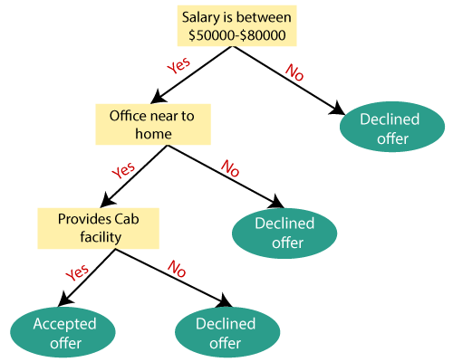

**Decision Tree Visualisation**

import matplotlib.pyplot as plt

%matplotlib inline

from sklearn.datasets import load_iris

from sklearn import tree

clf = tree.DecisionTreeClassifier(random_state = 0)

iris = load_iris()

clf = clf.fit(iris.data, iris.target)

plt.figure(figsize = (18,10))

tree.plot_tree(clf, filled = True)

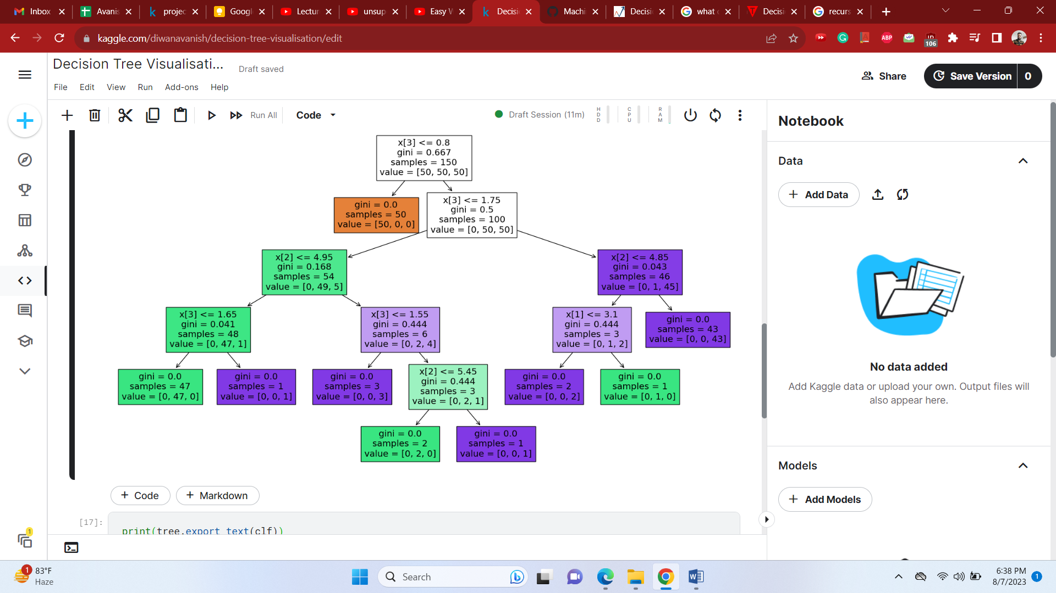

print(tree.export_text(clf))

# the above code details how the visualization works.

## Attribute Selection Measures

While implementing a Decision tree, the main issue arises that how to select the best attribute for the root node and for sub-nodes. So, to solve such problems there is a technique which is called as **Attribute selection measure or ASM.**By this measurement, we can easily select the best attribute for the nodes of the tree. There are two popular techniques for ASM, which are:

* **Information Gain**
* **Gini Index**

### **1. Information Gain:**

* Information gain is the measurement of changes in entropy after the segmentation of a dataset based on an attribute.
* It calculates how much information a feature provides us about a class.
* According to the value of information gain, we split the node and build the decision tree.
* A decision tree algorithm always tries to maximize the value of information gain, and a node/attribute having the highest information gain is split first. It can be calculated using the below formula:

Information Gain= Entropy(S)- [(Weighted Avg) *Entropy(each feature)

**Entropy:** Entropy is a metric to measure the impurity in a given attribute. It specifies randomness in data. Entropy can be calculated as:

Entropy(s)= -P(yes)log2 P(yes)- P(no) log2 P(no)

**Where,**

* **S= Total number of samples**
* **P(yes)= probability of yes**
* **P(no)= probability of no**

### **2. Gini Index:**

* Gini index is a measure of impurity or purity used while creating a decision tree in the CART(Classification and Regression Tree) algorithm.
* An attribute with the low Gini index should be preferred as compared to the high Gini index.
* It only creates binary splits, and the CART algorithm uses the Gini index to create binary splits.
* Gini index can be calculated using the below formula:

Gini Index= 1- ∑jPj2

## To know ASM in detail refer below journal:

## [https://towardsdatascience.com/decision-trees-explained-entropy-information-gain-gini-index-ccp-pruning-4d78070db36c#:~:text=The%20Gini%20Index%20or%20Impurity,lower%20the%20likelihood%20of%20misclassification.&text=P(i)%20represents%20the%20ratio,of%20observations%20in%20node.](https://towardsdatascience.com/decision-trees-explained-entropy-information-gain-gini-index-ccp-pruning-4d78070db36c%23:~:text=The%20Gini%20Index%20or%20Impurity,lower%20the%20likelihood%20of%20misclassification.&text=P(i)%20represents%20the%20ratio,of%20observations%20in%20node.)

**Entropy v/s Gini Impurity:**Now we have learned about Gini Impurity and Entropy and how it actually works. Also, we have seen how we can calculate Gini Impurity/Entropy for a split/feature. But the major question that arises here is why do we need to have both methods for computation and which is better.

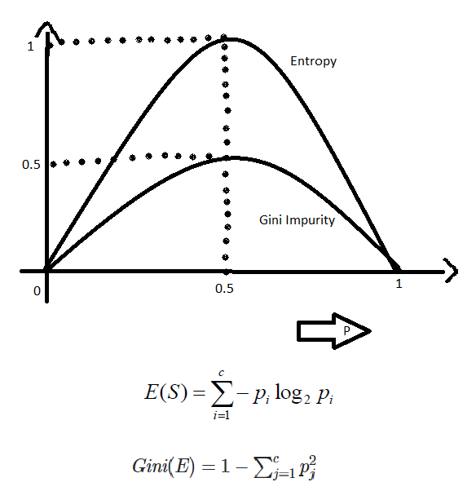

The internal working of both methods is very similar and both are used for computing the feature/split after every new splitting. But if we compare both methods then Gini Impurity is more efficient than entropy in terms of computing power. As you can see in the graph for entropy, it first increases up to 1 and then starts decreasing, but in the case of Gini impurity it only goes up to 0.5 and then it starts decreasing, hence it requires less computational power. The range of Entropy lies in between 0 to 1 and the range of Gini Impurity lies between 0 to 0.5. Hence we can conclude that Gini Impurity is better as compared to entropy for selecting the best features.

**Difference between Gini Index and Entropy**

|  |  |
| --- | --- |
| It is the probability of misclassifying a randomly chosen element in a set. | While entropy measures the amount of uncertainty or randomness in a set. |
| The range of the Gini index is [0, 1], where 0 indicates perfect purity and 1 indicates maximum impurity. | The range of entropy is [0, log(c)], where c is the number of classes. |
| Gini index is a linear measure. | Entropy is a logarithmic measure. |
| It can be interpreted as the expected error rate in a classifier. | It can be interpreted as the average amount of information needed to specify the class of an instance. |
| It is sensitive to the distribution of classes in a set. | It is sensitive to the number of classes. |
| The computational complexity of the Gini index is O(c). | Computational complexity of entropy is O(c * log(c)). |
| It is less robust than entropy. | It is more robust than Gini index. |
| It is sensitive. | It is comparatively less sensitive. |
| Formula for the Gini index is Gini(P) = 1 – ∑(Px)^2, where Pi is  the proportion of the instances of class x in a set. | Formula for entropy is Entropy(P) = -∑(Px)log(Px), where pi is the proportion of the instances of class x in a set. |
| It has a bias toward selecting splits that result in a more balanced distribution of classes. | It has a bias toward selecting splits that result in a higher reduction of uncertainty. |
| Gini index is typically used in CART (Classification and Regression Trees) algorithms | Entropy is typically used in ID3 and C4.5 algorithms |

***Conclusion:****It ought to be emphasized that there is no one appropriate approach for evaluating unpredictability or impurities, and that the decision between the Gini index and entropy varies significantly on the particular circumstance and methodology being employed.*

## 

## 

The CART algorithm for regression works mostly the same way as earlier, except that instead of trying to split the training set in a way that minimizes impurity, it now tries to split the training set in a way that minimizes the MSE. Equation 6-4 shows the cost function that the algorithm tries to minimize.



Now, we will explore both a binary classification and regression model using decision trees with the [Indian Graduate Admissions dataset](https://www.kaggle.com/mohansacharya/graduate-admissions).

### Dataset

The data contains features commonly used in determining admission to masters’ degree programs, such as GRE, GPA, and letters of recommendation. The complete list of features is summarized below:

* GRE Scores ( out of 340 )
* TOEFL Scores ( out of 120 )
* University Rating ( out of 5 )
* Statement of Purpose and Letter of Recommendation Strength ( out of 5 )
* Undergraduate GPA ( out of 10 )
* Research Experience ( either 0 or 1 )
* Chance of Admit ( ranging from 0 to 1 )

We’re going to begin by loading the dataset as a pandas DataFrame. Feel free to open up a jupyter notebook on the side to implement the code in the article!

import pandas as pd

df = pd.read_csv("Admission_Predict.csv")

df.columns = df.columns.str.strip().str.replace(' ','_').str.lower()

## Decision Trees for Classification: A Recap

As a first step, we will create a binary class (1=admission likely , 0=admission unlikely) from the chance of admit – greater than 80% we will consider as likely. The remaining data columns will be used as predictors.

X = df.loc[:,'gre_score':'research']

y = df['chance_of_admit']>=.8

### Fitting and Predicting

We will use scikit-learn‘s tree module to create, train, predict, and visualize a decision tree classifier. The syntax is the same as other models in scikit-learn, once an instance of the model class is instantiated with

 dt = DecisionTreeClassifier(), .fit() can be used to fit the model on the training set. After fitting, .predict() (and predict_proba()) and .score() can be called to generate predictions and score the model on the test data.

As with other scikit-learn models, only numeric data can be used (categorical variables and nulls must be handled prior to model fitting). In this case, our categorical features have already been transformed and no missing values are present in the data set.

x_train, x_test, y_train, y_test = train_test_split(X,y, random_state=0, test_size=0.2)

dt = DecisionTreeClassifier(max_depth=2, ccp_alpha=0.01,criterion='gini')

dt.fit(x_train, y_train)

y_pred = dt.predict(x_test)

print(dt.score(x_test, y_test))

print(accuracy_score(y_test, y_pred))

Output:

0.925

0.925

Two methods are available to visualize the tree within the tree module – the first is using tree_plot to graphically represent the decision tree. The second uses export_text to list the rules behind the splits in the decision tree. There are many other packages available for more visualization options – such as graphviz, but may require additional installations and will not be covered here.

tree.plot_tree(dt, feature_names = x_train.columns,

max_depth=3, class_names = ['unlikely admit', 'likley admit'],

label='root', filled=True)

print(tree.export_text(dt, feature_names = X.columns.tolist()))

Output:

|--- cgpa <= 8.85

| |--- class: False

|--- cgpa > 8.85

| |--- gre_score <= 313.50

| | |--- class: False

| |--- gre_score > 313.50

| | |--- class: True

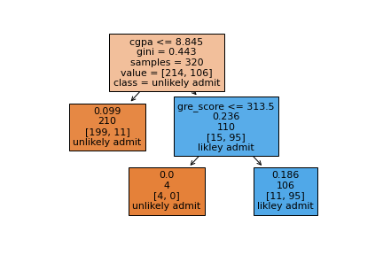

### Split Criteria

For a classification task, the default split criteria is Gini impurity – this gives us a measure of how “impure” the groups are. At the root node, the first split is then chosen as the one that maximizes the information gain, i.e. decreases the Gini impurity the most. Our tree has already been built for us, but how was the split cgpa<=8.845 determined? cgpa is a continuous variable, which adds an extra complication, as the split can occur for ANY value of cgpa.

To verify, we will use the defined functions gini and info_gain. By running gini(y_train), we get the same Gini impurity value as printed in the tree at the root node, 0.443.

def gini(data):

"""Calculate the Gini Impurity Score

"""

data = pd.Series(data)

return 1 - sum(data.value_counts(normalize=True)**2)

gi = gini(y_train)

print(f'Gini impurity at root: {round(gi,3)}')

Output:

Gini impurity at root: 0.443

def info_gain(left, right, current_impurity):

"""Information Gain associated with creating a node/split data.

Input: left, right are data in left branch, right banch, respectively

current_impurity is the data impurity before splitting into left, right branches

"""

# weight for gini score of the left branch

w = float(len(left)) / (len(left) + len(right))

return current_impurity - w * gini(left) - (1 - w) * gini(right)

Next, we are going to verify how the split on cgpa was determined, i.e. where did the 8.845 value come from. We will use info_gain over ALL values of cgpa to determine the information gain when split on each value. This is stored in a table and sorted, and voila, the top value for the split is cgpa<=8.845! This is also done for every other feature (and for those continuous ones, every value), to find the top split overall.

info_gain_list = []

for i in x_train.cgpa.unique():

left = y_train[x_train.cgpa<=i]

right = y_train[x_train.cgpa>i]

info_gain_list.append([i, info_gain(left, right, gi)])

ig_table = pd.DataFrame(info_gain_list, columns=['split_value', 'info_gain']).sort_values('info_gain',ascending=False)

ig_table.head(10)

Output:

| |split_value | info_gain |

|---|-----|-----|

| 10 | 8.84 | 0.296932 |

| 124 | 8.85 | 0.291464 |

| 139 | 8.88 | 0.290704 |

| 18 | 8.90 | 0.290054 |

| 98 | 8.83 | 0.287810 |

| 110 | 8.87 | 0.286050 |

| 152 | 8.94 | 0.284714 |

| 57 | 8.96 | 0.284210 |

| 96 | 8.80 | 0.283371 |

| 21 | 9.00 | 0.283364 |

plt.plot(ig_table['split_value'], ig_table['info_gain'],'o')

plt.plot(ig_table['split_value'].iloc[0], ig_table['info_gain'].iloc[0],'r*')

plt.xlabel('cgpa split value')

plt.ylabel('info gain')

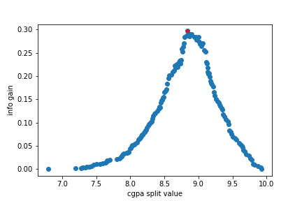

After this process is repeated, and there is no further info gain by splitting, the tree is finally built. Last to evaluate, any sample traverses through tree and appropriate splits until it reaches a leaf node, and then assigned the majority class of that leaf (or weighted majority).

## Regression

For the regression problem, we will use the unaltered chance_of_admit target, which is a floating point value between 0 and 1.

X = df.loc[:,'gre_score':'research']

y = df['chance_of_admit']

### Fitting and Predicting

The syntax is identical as the decision tree classifier, except the target, y, must be real-valued and the model used must be DecisionTreeRegressor(). As far as the model hyperparameters go, almost all are the same, except for the split criterion. The split criterion now needs be suitable for a regression task – the default for regression is Mean Squared Error (or MSE). Let’s investigate this:

x_train, x_test, y_train, y_test = train_test_split(X,y, random_state=0, test_size=0.2)

dt = DecisionTreeRegressor(max_depth=3, ccp_alpha=0.001)

dt.fit(x_train, y_train)

y_pred = dt.predict(x_test)

print(dt.score(x_test, y_test))

Similarly, the tree can be visualized using tree.plot_tree – keeping in mind the splitting criteria is mse and the value is the average chance_of_admit of all samples in that leaf.

plt.figure(figsize=(10,10))

tree.plot_tree(dt, feature_names = x_train.columns,

max_depth=2, filled=True);

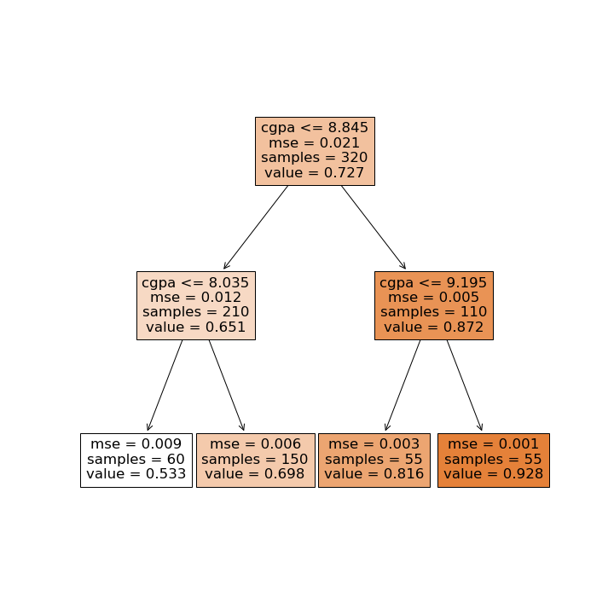

### Split Criteria

Unlike the classification problem, there are no longer classes to split the tree by. Instead, at each level, the value is the average of all samples that fit the logical criteria. In terms of evaluating the split, the default method is MSE. For example, the root node, the average target value is 0.727 (verify y_train.mean()). Then the MSE (mean-squared error) if we were to use 0.727 as the value for all samples, would be:

np.mean((y_train - y_train.mean())**2) = 0.02029

Now to determine the split, for each value of cpga, the information gain, or decrease in MSE after the split, is calculated and then values are sorted. Like before, we can modify our functions for the regression version, and see the best split is again cpga<=8.84.

The below code walks you through the details – in the regression version, instead of Gini impurity, MSE is used, and the information gain function is modified to mse_gain.

def mse(data):

"""Calculate the MSE of a data set

"""

return np.mean((data - data.mean())**2)

def mse_gain(left, right, current_mse):

"""Information Gain (MSE) associated with creating a node/split data based on MSE.

Input: left, right are data in left branch, right banch, respectively

current_impurity is the data impurity before splitting into left, right branches

"""

# weight for gini score of the left branch

w = float(len(left)) / (len(left) + len(right))

return current_mse - w * mse(left) - (1 - w) * mse(right)

m = mse(y_train)

print(f'MSE at root: {round(m,3)}')

mse_gain_list = []

for i in x_train.cgpa.unique():

left = y_train[x_train.cgpa<=i]

right = y_train[x_train.cgpa>i]

mse_gain_list.append([i, mse_gain(left, right, m)])

mse_table = pd.DataFrame(mse_gain_list,columns=['split_value', 'info_gain']).sort_values('info_gain',ascending=False)

print(mse_table.head(10))

Output:

MSE at root: 0.021

split_value info_gain

10 8.84 0.011065

96 8.80 0.011037

98 8.83 0.011023

124 8.85 0.010985

125 8.73 0.010939

110 8.87 0.010932

139 8.88 0.010895

1 8.70 0.010894

17 8.76 0.010858

140 8.74 0.010850

plt.plot(mse_table['split_value'], mse_table['info_gain'],'o')

plt.plot(mse_table['split_value'].iloc[0], mse_table['info_gain'].iloc[0],'r*')

plt.xlabel('cgpa split value')

plt.ylabel('info gain')

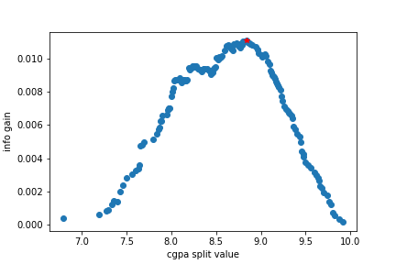

Again, the process will continue until there is no increase in information gain by splitting. Now that the tree has been built, evaluation occurs in pretty much the same way. Any sample traverses through the tree until it reaches a leaf node and is then assigned the average value of the samples in leaf. Depending on the depth of the tree, the predicted values can be limited. In this example, only four unique predicted values are possible, which we can verify. This is something to be aware of when using a decision tree regressor, unlike linear/logistic regression, not all output values may be possible.

np.unique(dt.predict(x_train))

Output:

array([0. , 0.00588235, 0.28571429, 0.32 , 0.63636364, 0.96428571])

### **Summary**

We’ve seen how decision trees can be used for both classification and regression tasks.

* The fundamental difference is that for classification, splits are based on Gini impurity error calculations whereas for regression, Mean Squared Error minimization is used.
* Tree traversal based on information gain and evaluation works pretty much the same way for both tasks.
* Decision tree regressors differ from other regressors in that all output values may not be possible and it depends on the depth of the tree.

## <https://www.codecademy.com/article/mlfun-decision-trees-article>

**Decision Tree algorithm application to large dataset vs small dataset**

The Decision Tree algorithm can be applied to both large and small datasets, but there are differences in how its performance and behavior might vary in each scenario:

**Decision Tree on Large Datasets:**

1. **Scalability:** Traditional Decision Trees can struggle with large datasets, as they are sensitive to the number of data points and features. Constructing a tree on a large dataset can become computationally expensive and memory-intensive.
2. **Overfitting:** On large datasets, Decision Trees are more prone to overfitting due to their ability to create complex, deep trees that perfectly fit the training data. Pruning techniques might be necessary to control overfitting.
3. **Tree Depth:** In order to avoid overfitting, limiting the depth of the tree might be necessary. However, shallow trees might not capture intricate relationships in the data.
4. **Feature Selection:** With many features, Decision Trees can become less effective in selecting the most relevant ones, leading to suboptimal splits.

**Decision Tree on Small Datasets:**

1. **Overfitting:** On small datasets, Decision Trees can potentially overfit as well, especially if the tree becomes too complex. Pruning and controlling tree depth are important.
2. **Interpretability:** Decision Trees are more interpretable with small datasets, as it's easier to trace the path of decisions from the root to the leaves.
3. **Feature Selection:** On small datasets, Decision Trees can effectively select relevant features and create simple, interpretable trees.
4. **Data Noise:** Decision Trees might be more sensitive to noise on small datasets, potentially leading to biased splits.

**Strategies for Improvement:**

For both large and small datasets, there are strategies you can employ to improve Decision Trees:

1. **Ensemble Methods:** If the dataset is large or complex, using ensemble methods like Random Forests or Gradient Boosting can improve the model's performance by combining multiple decision trees.
2. **Feature Engineering:** Creating informative features can improve the effectiveness of Decision Trees in both scenarios.
3. **Pruning:** Pruning techniques help prevent overfitting by limiting the depth of the tree or removing branches that do not contribute significantly to the model's accuracy.
4. **Cross-Validation:** Perform cross-validation to assess the model's performance and adjust hyperparameters accordingly.
5. **Data Preprocessing:** For both large and small datasets, preprocess the data by handling missing values, outliers, and encoding categorical variables appropriately.

In summary, while Decision Trees can be applied to both large and small datasets, they exhibit different behaviors and challenges in each case. For larger datasets, ensemble methods might be more effective, while for smaller datasets, Decision Trees can be a powerful and interpretable choice when appropriately controlled to prevent overfitting.

**Is decision tree algorithm sensitive to outlier?**

Yes, the Decision Tree algorithm can be sensitive to outliers, especially in cases where the outliers significantly affect the feature space. Outliers are data points that deviate significantly from the rest of the dataset, and they can influence the decisions made by Decision Trees in the following ways:

1. **Split Decisions:** Outliers might lead to decisions that are biased towards these extreme values. If an outlier appears in a node during the tree construction, the decision boundary could be skewed to accommodate that outlier.
2. **Tree Depth:** Outliers can lead to deep, overly complex trees as the algorithm tries to accommodate them. This might result in overfitting, where the tree captures noise instead of true patterns.
3. **Inaccurate Predictions:** Outliers can cause errors in predictions, as Decision Trees tend to predict the target value based on the majority class in a leaf node. If an outlier is incorrectly classified, it could impact predictions.

**Mitigation Strategies:**

1. **Outlier Detection and Handling:** Identify and handle outliers using techniques like z-score, IQR (interquartile range), or domain-specific knowledge. You might choose to remove them, cap them, or transform them to minimize their impact.
2. **Pruning:** To counteract the impact of outliers on tree depth and complexity, pruning techniques can be used to limit tree growth and avoid overfitting.
3. **Ensemble Methods:** If outliers are causing problems, using ensemble methods like Random Forests can help mitigate their impact. Random Forests build multiple trees and average their predictions, reducing the impact of individual outliers.
4. **Data Transformation:** Applying transformations to the data, such as log transformations, can help reduce the influence of extreme values.
5. **Feature Scaling:** Normalizing or standardizing features can make the Decision Tree algorithm less sensitive to the scale of the data, including outliers.

In summary, while Decision Trees can be sensitive to outliers, there are strategies you can use to mitigate their effects. It's important to assess the impact of outliers on your specific dataset and problem and choose appropriate techniques to handle them while building accurate and robust models.

**Effect of missing values on decision tree algorithm**

The Decision Tree algorithm has certain characteristics that make it relatively robust to missing values compared to some other algorithms. However, the presence of missing values can still affect the behavior and performance of Decision Trees in various ways:

**Impact of Missing Values on Decision Trees:**

1. **Handling Missing Values:**
   * Decision Trees can handle missing values directly without requiring explicit imputation.
   * During the tree construction process, if a data point has a missing value for a particular feature, it can be directed down multiple branches based on the available information.
2. **Bias in Split Decisions:**
   * If a feature with missing values is used for a split, the algorithm can make a decision that disproportionately favors the non-missing values, potentially introducing bias.
3. **Impact on Split Priority:**
   * Features with missing values might not always be selected for splitting if other features have lower impurity measures. This can lead to less optimal decisions.
4. **Handling Categorical Missing Values:**
   * Categorical features with missing values can be treated as a separate category during tree construction, allowing the algorithm to make decisions for those missing values based on the majority class in the node.

**Strategies to Address Missing Values:**

1. **Missingness Indicator:**
   * Create an additional binary feature that indicates whether a value is missing. This might capture potential patterns in missingness that could be predictive.
2. **Strategic Imputation:**
   * Although Decision Trees don't require imputation, you can fill in missing values using techniques that make sense for your data. For example, you could replace missing values with the mean, median, mode, or some other value.
3. **Weighted Impurity Measures:**
   * Modify the impurity measures (such as Gini impurity) to account for missing values in a way that the algorithm can still make informed decisions.
4. **Ensemble Methods:**
   * Ensemble methods like Random Forests can further mitigate the impact of missing values by averaging predictions from multiple Decision Trees.
5. **Data Transformation:**
   * Transforming features (logarithmic, square root, etc.) can help reduce the impact of missing values on the tree-building process.

In summary, Decision Trees can handle missing values more gracefully than some other algorithms, but the presence of missing values can still affect their behavior. Depending on the extent and nature of missingness, using appropriate strategies, such as creating indicators, making strategic imputations, and utilizing ensemble methods, can help you build accurate and robust Decision Tree models.

**Effect of correlation on decision tree algorithm**

The effect of correlation on the Decision Tree algorithm can impact how the algorithm constructs the tree and makes split decisions. Here's how correlation among features can influence Decision Trees:

**Positive Correlation:**

1. **Feature Redundancy:** When two or more features are highly positively correlated, they might carry similar information. The Decision Tree algorithm might favor one of the correlated features during the split decisions, potentially ignoring others. This can lead to a suboptimal use of available information.
2. **Bias in Split Decisions:** The algorithm might be biased towards selecting the correlated feature that appears earlier in the tree construction, even if other correlated features are equally informative.
3. **Tree Depth and Complexity:** If correlated features are present, the algorithm might create deeper trees than necessary to accommodate the additional information they provide. This can potentially lead to overfitting.

**Negative Correlation:**

1. **Informative Splits:** Negative correlation can provide useful complementary information. When one feature indicates high values, the negatively correlated feature might indicate low values, resulting in informative splits.
2. **Improved Generalization:** Negative correlation can help in achieving better generalization by preventing the algorithm from creating overly specific splits.

**Strategies to Address Correlation:**

1. **Feature Selection:** In the presence of highly correlated features, consider performing feature selection to choose the most relevant ones. This can help in simplifying the model and reducing the impact of multicollinearity.
2. **Feature Engineering:** Create new features that capture the essence of the correlation. This might involve creating ratios, differences, or interactions between correlated features.
3. **PCA or Dimensionality Reduction:** Techniques like Principal Component Analysis (PCA) can be applied to reduce the dimensionality of correlated features while preserving their variance.
4. **Random Forests:** If you're concerned about the impact of correlated features, using ensemble methods like Random Forests can help mitigate this effect. Random Forests average the predictions of multiple Decision Trees, reducing the bias towards specific features.
5. **Validation and Testing:** Experiment with different scenarios by including or excluding correlated features to observe how they impact model performance using cross-validation.

In summary, the effect of correlation on Decision Trees can vary depending on the degree and nature of correlation. While Decision Trees can be sensitive to correlated features, there are strategies you can employ to manage their impact and ensure your model's robustness and interpretability.

## Feature Engineering, Feature Selection and Feature Importance in decision tree algorithm

**Feature Engineering:** Feature engineering involves creating new features or transforming existing ones to improve the performance of a machine learning model. Here's how it applies to Decision Trees:

1. **Creating New Features:**
   * Develop new features by combining existing ones to capture relevant interactions or patterns.
2. **Transformations:**
   * Apply mathematical transformations (logarithm, square root, etc.) to make the feature distributions more suitable for modeling.
3. **Categorical Variable Handling:**
   * Convert categorical variables into numerical format using techniques like one-hot encoding or label encoding.
4. **Time-Series Features:**
   * Create lag features for time-series data to capture temporal dependencies.

**Feature Selection:** Feature selection involves choosing a subset of relevant features to include in the model. Decision Trees have some built-in mechanisms for feature selection:

1. **Feature Importance:**
   * Decision Trees provide feature importance scores that indicate how much each feature contributes to the model's predictive performance.
2. **Pruning:**
   * Pruning is a process of removing branches that do not contribute significantly to the model's accuracy, effectively simplifying the tree and selecting more important features.

**Feature Importance:** Feature importance helps you understand the contribution of each feature to the model's predictions. Here's how it's calculated in Decision Trees:

1. **Gini Importance:**
   * The decrease in impurity (usually measured by Gini impurity) for each feature is averaged across all nodes where the feature is used to make a split.
2. **Visualization:**
   * Visualize feature importance scores using bar charts to identify which features have the most impact on the model.
3. **Interpretation:**
   * Feature importance scores help you understand which features are driving the decision-making process in the Decision Tree.

**Strategies for Effective Use:**

1. **Experimentation:** Try different feature engineering techniques to create new informative features, and experiment with various ways to transform and encode data.
2. **Cross-Validation:** Use cross-validation to assess the impact of different feature subsets on your Decision Tree model's performance.
3. **Validation and Testing:** After engineering features and selecting relevant ones, validate your model's performance on new, unseen data to ensure its generalization capabilities.
4. **Ensemble Methods:** If Decision Trees' performance is still suboptimal, consider using ensemble methods like Random Forests or Gradient Boosting to combine multiple Decision Trees and improve predictive accuracy.

In summary, effective feature engineering, selection, and understanding of feature importance can significantly impact the performance and interpretability of Decision Trees. Experimentation and validation are key to finding the right combination of features for your specific problem.

**How to handle overfitting issue in Decision Tree**

Overfitting is a common challenge in the Decision Tree algorithm, where the model becomes too complex and fits the training data noise, leading to poor generalization on unseen data. To mitigate overfitting in Decision Trees, you can employ several strategies:

1. **Pruning:**
   * Pruning involves removing branches from the tree that do not significantly improve predictive accuracy on validation data. This reduces the complexity of the tree, preventing it from capturing noise in the training data.
2. **Limiting Tree Depth:**
   * Limit the maximum depth of the tree during construction. Shallow trees are less likely to overfit as they capture general patterns rather than noise.
3. **Minimum Samples per Leaf or Split:**
   * Set thresholds for the minimum number of samples required in a leaf node or for splitting a node. This helps prevent small subsets of data from being used to make decisions.
4. **Minimum Impurity Decrease:**
   * Set a threshold for the minimum impurity decrease required for a split. If a potential split doesn't achieve a sufficient impurity reduction, the split is not performed.
5. **Feature Selection:**
   * Perform feature selection to choose the most relevant features, reducing the likelihood of overfitting on irrelevant or noisy features.
6. **Ensemble Methods:**
   * Use ensemble methods like Random Forests or Gradient Boosting, which combine multiple Decision Trees to improve generalization. These methods help average out the individual trees' tendencies to overfit.
7. **Cross-Validation:**
   * Employ cross-validation to assess how well your Decision Tree model generalizes to new data. This can help you identify whether overfitting is occurring and guide your adjustments.
8. **Validation Set:**
   * Reserve a portion of your training data as a validation set. Monitor the model's performance on this set during training and stop training when performance on the validation set starts to degrade.
9. **Data Augmentation:**
   * Introduce data augmentation techniques to artificially increase your dataset's size by adding slightly modified versions of existing data. This can help prevent overfitting by exposing the model to more variations.
10. **Hyperparameter Tuning:**
    * Experiment with different hyperparameters like maximum depth, minimum samples per leaf, or impurity decrease thresholds to find the settings that result in better generalization.

Remember that the strategies you choose depend on your specific dataset, problem, and the nature of overfitting you're observing. It's a good practice to try multiple techniques in combination and to validate your model's performance using techniques like cross-validation or a hold-out validation set.